**SOP- DUO Authentication Setup**



|  |  |
| --- | --- |
| Owner | Sysnet |
| Created | 19th Aug 2021 |
| Revision/Version | 1.0 |
| Revision date | - |

Document Version

|  |  |  |  |  |  |
| --- | --- | --- | --- | --- | --- |
| Revision/Version | Description | Date | Author | Reviewed by | Approved by |
| 1.0 | Initial Release | 19/08/2021 | Vaman Dhuri | Kailash Oswal |  |

**Steps to setup DUO authentication**

1). Open browser and enter the URL <https://xornet.xoriant.com> it will redirect you to Xoriant ADFS page, Enter your MS Outlook credentials and Sign in.

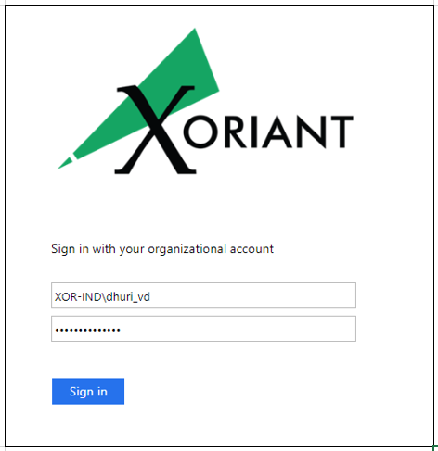

2). Once signed in it will redirect to Cisco Duo enrollment page for 2FA. Click on Start Setup.

3). Select Mobile phone.

4). Select Country and Enter your mobile number.

5). Select type of Phone. If Other (and cell phones)” option is selected, skip step #6 & #7.

6). Install Cisco Duo app on your mobile from App store and click on “I have Duo Mobile”.

7). Scan QR code through Duo app in your mobile and click continue.

8). Once Done Select Log in method and click on “Continue to Login”.

9). If you click on Send Me a Push it will send Push on your Mobile, you need to approve it for login or if you select Enter a Passcode you need to enter six digit code from Duo app and click on login. After clicking on “Enter a Passcode”, if you want to receive the passcode as an SMS, click on “Text me new codes” button. Enter the text code received and click on “Log in”.

End of the SOP- DUO Authentication Setup